Data type and structure worksheet

1. Data types can be defined using pseudocode.  
   The data type, ComputerRecord, is defined by the following pseudocode:  
     
   TYPE ComputerRecord

DECLARE ComputerID : INTEGER

DECLARE ComputerType : (Laptop, Desktop, Tablet)

DECLARE ComputerLocation : (Lab1, Lab2, Lab3, Mobile)

DECLARE DateTested : DATE

ENDTYPE

A variable, SchoolComputer, is declared in pseudocode as:

*DECLARE SchoolComputer : ComputerRecord*

(a) Write pseudocode statements to assign 1234 to the ComputerID of SchoolComputer and Lab2 to the ComputerLocation of SchoolComputer.

.......................................................................................................................................................................................................................................................... [2]

(b) The type definition for ComputerRecord is changed.

(i) The definition has been extended to include the student identification numbers,

StudentID, for up to 20 students who can use that computer. Each student identification number is an integer.

Write the extra line of pseudocode needed in the type definition for ComputerRecord.

........................................................................................................................................................................................................................................................... [1]

(ii) The values for the field ComputerID must be between 1000 and 1999 inclusive.

Rewrite one pseudocode line from the type definition of ComputerRecord to implement the change.

........................................................................................................................................................................................................................................................... [1]

c) Data about all the computers are stored in a file that uses random file organisation.

ComputerID is used as the key field.

Explain how a program could search for a record stored in this file.

............................................................................................................................................................................................................................................................................................................................................................................................................................................................................................................................................................................................................................................................................................................................................................................................ [3

1. Data types can be classified as composite or non-composite.  
   A record is declared of type box using the following pseudocode.  
   *TYPE size = (small, medium, large)  
   TYPE box  
    DECLARE volume : size  
    DECLARE price : REAL  
    DECLARE colour : STRING  
   ENDTYPE  
   DECLARE myBox : ARRAY [1:6] OF box*

(a) (i) Identify one composite and three non-composite data types used in the pseudocode.

Composite data type ..............................................................................................

Non-composite data type 1 .....................................................................................

Non-composite data type 2 .....................................................................................

Non-composite data type 3 ....................................................................................

[4]

(ii) Identify the data type in the pseudocode that is enumerated.

.......................................................................................................................... [1]

(b) A box is red, with medium volume and a price of $10.99.

Write pseudocode to store the details of this box in the first element of the array.

...................................................................................................................................................................................................................................................................................................................................................................................................................................................................................................................................................................................................................................................... [3]

1. Data types can be classified as composite or non-composite.
2. Draw one line from each data type to its correct classification

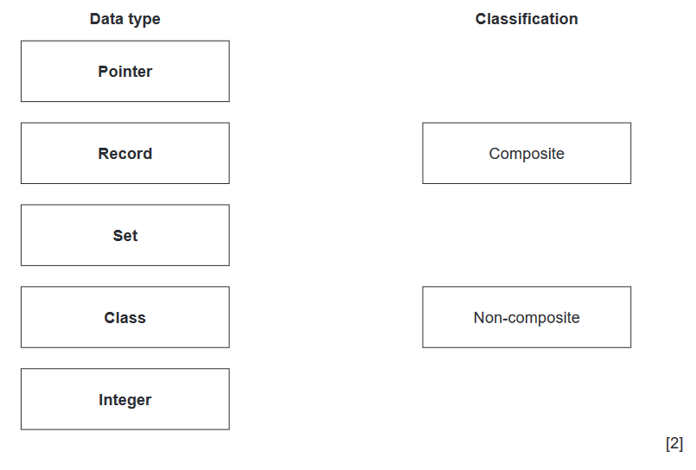

(b) A user-defined data type, timeOfDay, is declared using the following pseudocode.

TYPE timeOfDay = (morning, afternoon, evening, night)

(i) Identify the type of user-defined data type declared and state its classification.

Type ...........................................................................................................

Classification .............................................................................................................[2]

(ii) Write pseudocode to declare the variable session of type timeOfDay.

Assign the value afternoon to the variable session.

................................................................................................................................................................................................................................................................................................................................................................................................................................................................................... [2]

1. a) A programmer draws a program flowchart to show the sequence of steps required to solve a problem.  
   Give the technical term for a sequence of steps that describe how to solve a problem.

...................................................................................................................................................................................................................................... [ 1]

b) The table lists some of the variables used in a program.

i) Complete the table by writing the most appropriate data type for each variable.  
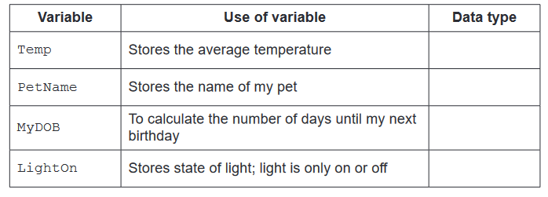   
 [4]

ii) One of the names used for a variable in the table in part 1( b) ( i) is not an example of good practice.

Identify the variable and give a reason why it is not good practice to use that name.

Variable ...........................................................................................................

Reason .............................................................................................................

................................................................................................................................................................................................................................................[2]

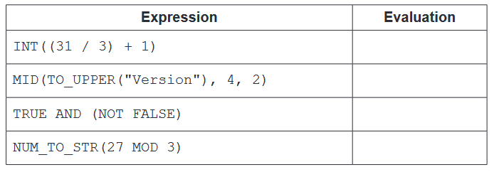   
 [4]

1. The manager of a cinema wants a program to allow users to book seats. The cinema has several screens. Each screen shows a different film.

a) Decomposition will be used to break the problem down into sub-problems.

Describe three program modules that could be used in the design.

Module 1 .......................................................................................................

....................................................................................................................................................................................................................................................

Module 2 ...........................................................................................................

....................................................................................................................................................................................................................................................

Module 3 ...........................................................................................................

....................................................................................................................................................................................................................................................

[3]

b) Two types of program modules may be used in the design of the program.

Identify the type of program module that should be used to return a value.

.................................................................................................................... [ 1]

1. (a) An algorithm will:

• output each integer value between 100 and 200 that ends with the digit 7, for example, 107

• output a final count of the number of values that are output.

Write pseudocode for this algorithm.

Any variables used must be declared.

......................................................................................................................................................................................................................................................................................................................................................................................................................................................................................................................................................................................................................................................................................................................................................................................................................................................................................................................................................................................................................................................................................................................................................................................................................................................................................................................................................................................................................................................................................................................................................................................................................................... [ 5 ]

b) Study the following pseudocode.  
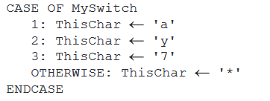

Write pseudocode with the same functionality without using a CASE structure.

............................................................................................................................................................................................................................................................................................................................................................................................................................................................................................................................................................................................................................................................................................................................................................................................................................................................................................................................................................................................................................................................................................................................................................................................................................................................................................................................................................................................................................................................................................................................................................................................................................................................................................................................................................................................................................................................................................................................................................................................................................................................................................................................................................................................................................................................................................................................................................................................................................................................................................................................................................................................................................................................ [ 4]

a) The following table contains pseudocode examples.

Each example may include all or part of:

• selection

• iteration (repetition)

• assignment.

Complete the table by placing one or more ticks (✓) in each row.  
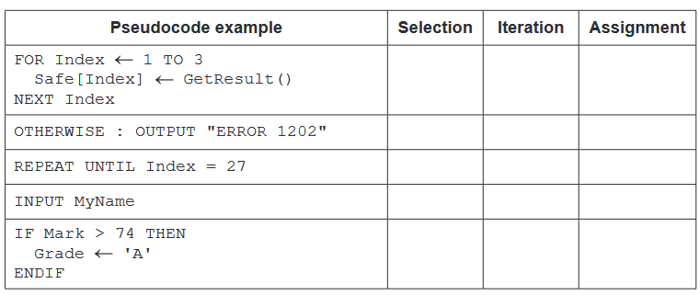

[4]

b) ( i) Program variables have values as follows:

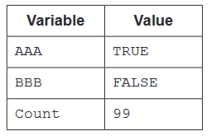

Complete the table by evaluating each expression

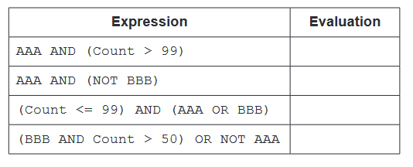[2]

ii) Give an example of when a variable of type Boolean would be used.

.............................................................................................................................................................................................................................................. [ 1]